David Epstein
Co-Founder, Tom’s Town Distilling Co.
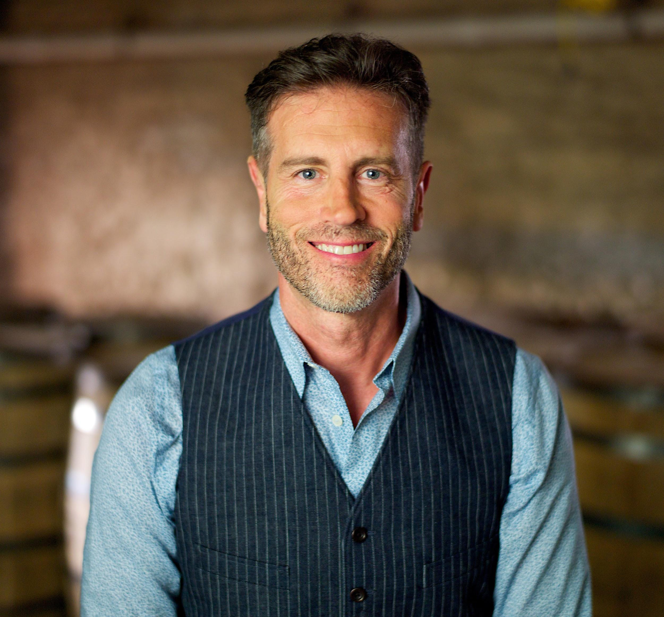
The grandson of a Kansas City bootlegger, David founded Tom’s Town Distilling Co in 2015 with his former business partner from BlairLake New Media. BlairLake was a pioneering digital advertising agency with offices in New York and Kansas City, and with clients like The Disney Channel, Lee Jeans and Sprint. Prior to starting BlairLake, David worked with his father as an attorney in Kansas City.

After BlairLake was acquired in 2000 by Compuware Corporation, David worked at NBC in New York City as Vice President of Digital Strategy, NBC Syndication.

But a combination of the pull of his hometown & his bootlegging roots to follow his grandfather’s footsteps in the business of booze...David returned home to build America’s best craft distillery.

